Introduction To DataBase

- Create Database


- Design Schema

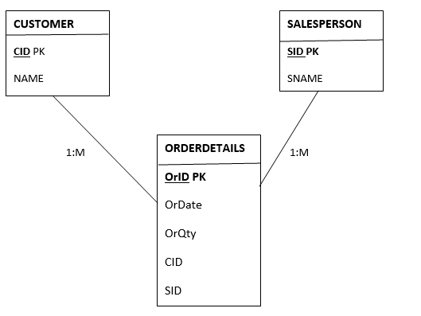

- Create tables
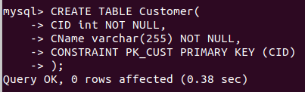

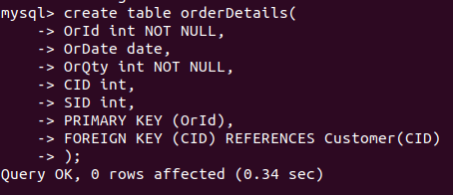

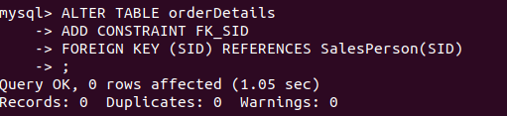

Insert sample data

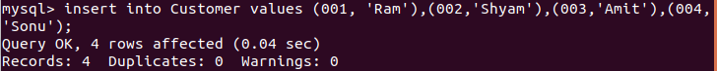
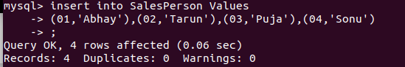

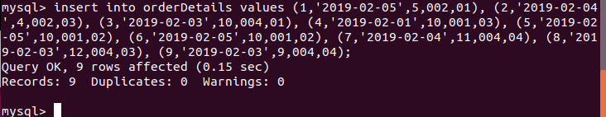
- Find the sales person have multiple orders.
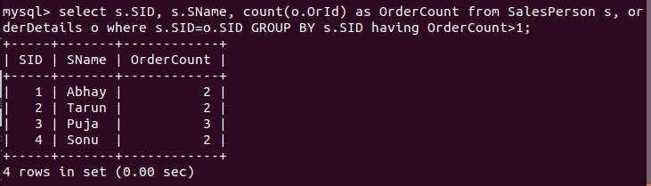

- Find the all sales person details along with order details
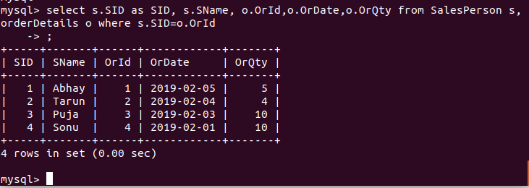

- Create index
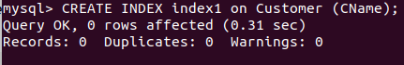

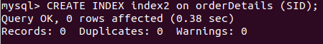

- How to show index on a table

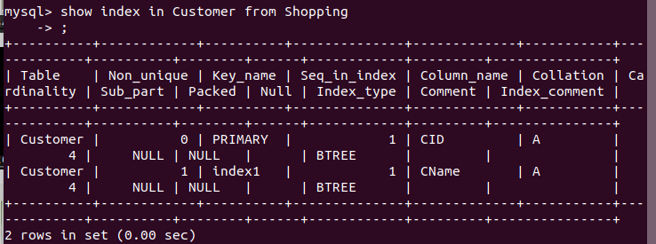

- Find the order number, sale person name, along with the customer to whom that order belongs to

